DESIGNING A WEBSITE FOR SOUTH SAVANNA GYM.
WEBSITE SPECIFICATION
South Savannah Gym is an urban situated gym that specializes in offering high quality gym services, products and personnel assistance for optimal fitness results. Located in the capital city of our country Gaborone Botswana, we have kept the discipline of delivering high quality services to our clients and had come up with the idea of constructing an informational website for our gym business.
Main purpose of website is to;
- To provide awareness to clients with our gym and promote familiarity from within the palm of their hands,
- To turn potential customers to clients,
- To retain the already existing clients for long term business partners,
- To gather informational feedback from our clients on sound development preferences,
- To provide information about fitness tools and training plans including other aspects that eases the clients to be disciplined in their journey,
- To entice the clients to keep on coming back to the gym hence being motivated on the long run to be business clients.
Our business has a target market of college students, youth, athletes and adults. We have strategically fashioned our gym facilities and services to cater for the needs and capabilities for the above mentioned individuals. Their key demographical features, technological capabilities and internet accessibility are;
- Age (range of 18 – 48 years),
- Gender (all sexes),
- Residence (within greater Gaborone region),
- Occupation (students, athletes and employed),
- Income level (lower middle affordability to higher affordability),
- Educational level (fairly educated and technically capable),
- Disabled (visually, audibly and verbally impaired),
- Religion and faith (accommodative to all faiths),
- Wide range use of computing technology,
- Good to best internet connection speeds (Gaborone and surroundings),
- Fair comprehension of web literacy.
The main concern is to combine the objectives of our website and the technical aptitude of our clients and their demographics to design the website that suits all of them. We want all users to use the website for their desired purposes wherever they are, to do whatever they want with whichever device they have through a connection and an input that they opt to use.
INFORMATION DESIGN AND TAXONOMY
Taxonomy refers to the naming and categorization of content in a hierarchy for easy navigation and accessibility purposes.
Information design refers to the presentation of content in a structured way for clear comprehension by the user (understand it quickly and clearly).
Our website is sectioned into different pages which are Home, About, Gym Facilities, Membership, Feedback and Contact pages. The key navigation through our website is set through the following path sectioned in the header section.
HOME - ABOUT - GYM - FACILITIES - MEMBERSHIP - FEEDBACK - CONTACT

HOME PAGE
HEADER SECTION
HERO CONTENT
MAIN CONTENT
TESTIMONIALS
BOOKING SECTION
FOOTER SECTION

ABOUT PAGE
HEADER SECTION
HERO CONTENT
MAIN CONTENT
FOOTER SECTION

GYM-FACILITIES
HEADER SECTION
HERO CONTENT
MAIN CONTENT
Aerobics
Cardio
Cycling
Gym equipment
Swimming
Trainers and Coaches
Sports Doctors and Dieticians
Training plan
FOOTER SECTION

MEMBERSHIP
HEADER SECTION
HERO CONTENT
MAIN CONTENT
STANDARD PACKAGE
PREMIUM PACKAGE
GOLD PACKAGE
FOOTER SECTION

FEEDBACK
HEADER SECTION
HERO CONTENT
MAIN CONTENT
FOOTER SECTION

CONTACT PAGE
HEADER SECTION
HERO CONTENT
MAIN CONTENT
FOOTER SECTION

HEADER SECTION - contains Gym Logo and the navigational menu to all the pages set up in a linear order from left to right.
HERO CONTENT - contains attention grabbing elements, calls to action and embedded content. These are for creating an urge for users to register with our gym and to entice them to keep on visiting the website thus helping retain them. It is also for creating an urge to potential customers to become clients.
MAIN CONTENT - contains the main content of the page opened.
TESTIMONIALS - overall gym atmosphere conclusions and feedback from previous gym members and ongoing ones.
BOOKING SECTION- this is the final destination that we want to entice users to land on as we call them to action.
CONTACT SECTION - contains information gym location and user friendly contact numbers, emails and social media platforms for reaching out.
FOOTER SECTION- contains all legal rights about the website. Copyrights, licensing and the owner of the website mentioned in this section.
Content is embedded strategically in these pages for structuring and organizational purposes in order to promote easy navigation and access by different users. Content is categorized and named according to hierarchy.
The informative content are named in the first pages of the website being Home page and about page. The content in these pages offers a clear picture of what the website is about and calls users to take action. The content in here should be organized in such a way that navigational features in it offers a good ease of travelling from the stated there in info as soon as possible. The testimonials and previous gym milestones visions are embedded and tailored in such an appealing manner for users to interact with the page and call to action to entice them to know more about the gym.
Hero section is meant for educational purposes and testimonial so as to drive users to actions like sign up and book a class.
Gym facilities then follows offering all about the facilities offered in our gym. Every flashy image embedded should correspond to the identified service back in the gym for authenticity purposes. Gym facility page consists of gym equipment, aerobics, swimming, cycling, trainers and coaches, training plan, sports doctors and dieticians and cardio pages.
Once the users knows about the facilities thereof we then provide an ease of navigation to the membership page where they see different gym membership packages. a flow of this hierarchy prevents users from going back and forth around the pages and to get information as it would not be structured. This is the naming in a form of hierarchy order and structuring of content. Membership offers different packages of membership fees that corresponds to the type of assistance and service one would like to get in the gym.
Feedback page is for user feedback about satisfaction about the page and to create room for improvements for overall website and gym. On Facebook, Virgin Active Botswana often posts apologies for disappointing experiences and requests that members provide further details via inbox for resolution. User feedback is often required to resolve issues within staff and gym members
There are hypertext lines or words highlighted to link related pages. There is a navigational bar at the header section for navigational purposes offering a dropdown feature for categorized services. The page enables users to navigate using both keyboard and a mouse to scroll through the navigation bar.

3. TECHNICAL BRIEF
Our website will be designed using Hypertext Markup Language (HTML5) for the website structure, Cascading Style Sheets (CSS3) for styling of page layout and Java Script for website responsiveness. Users will be able to operate with different devices, resolutions and operating systems when using the website as it is tailored to favor such tools. It is hosted on Git Hub web pages where we created a repository and loaded files coded using VS Code. A domain name is provided for our web page and Uniform Resource Locator file.

PAGE TEMPLATE CREATION
These are the page templates for South Savanna Gym Website. They offer a clear picture of placement of content detail sections and the navigational features through the website as whole. They consist of home, about, gym facilities, membership, feedback and contact web pages.

Home Web page
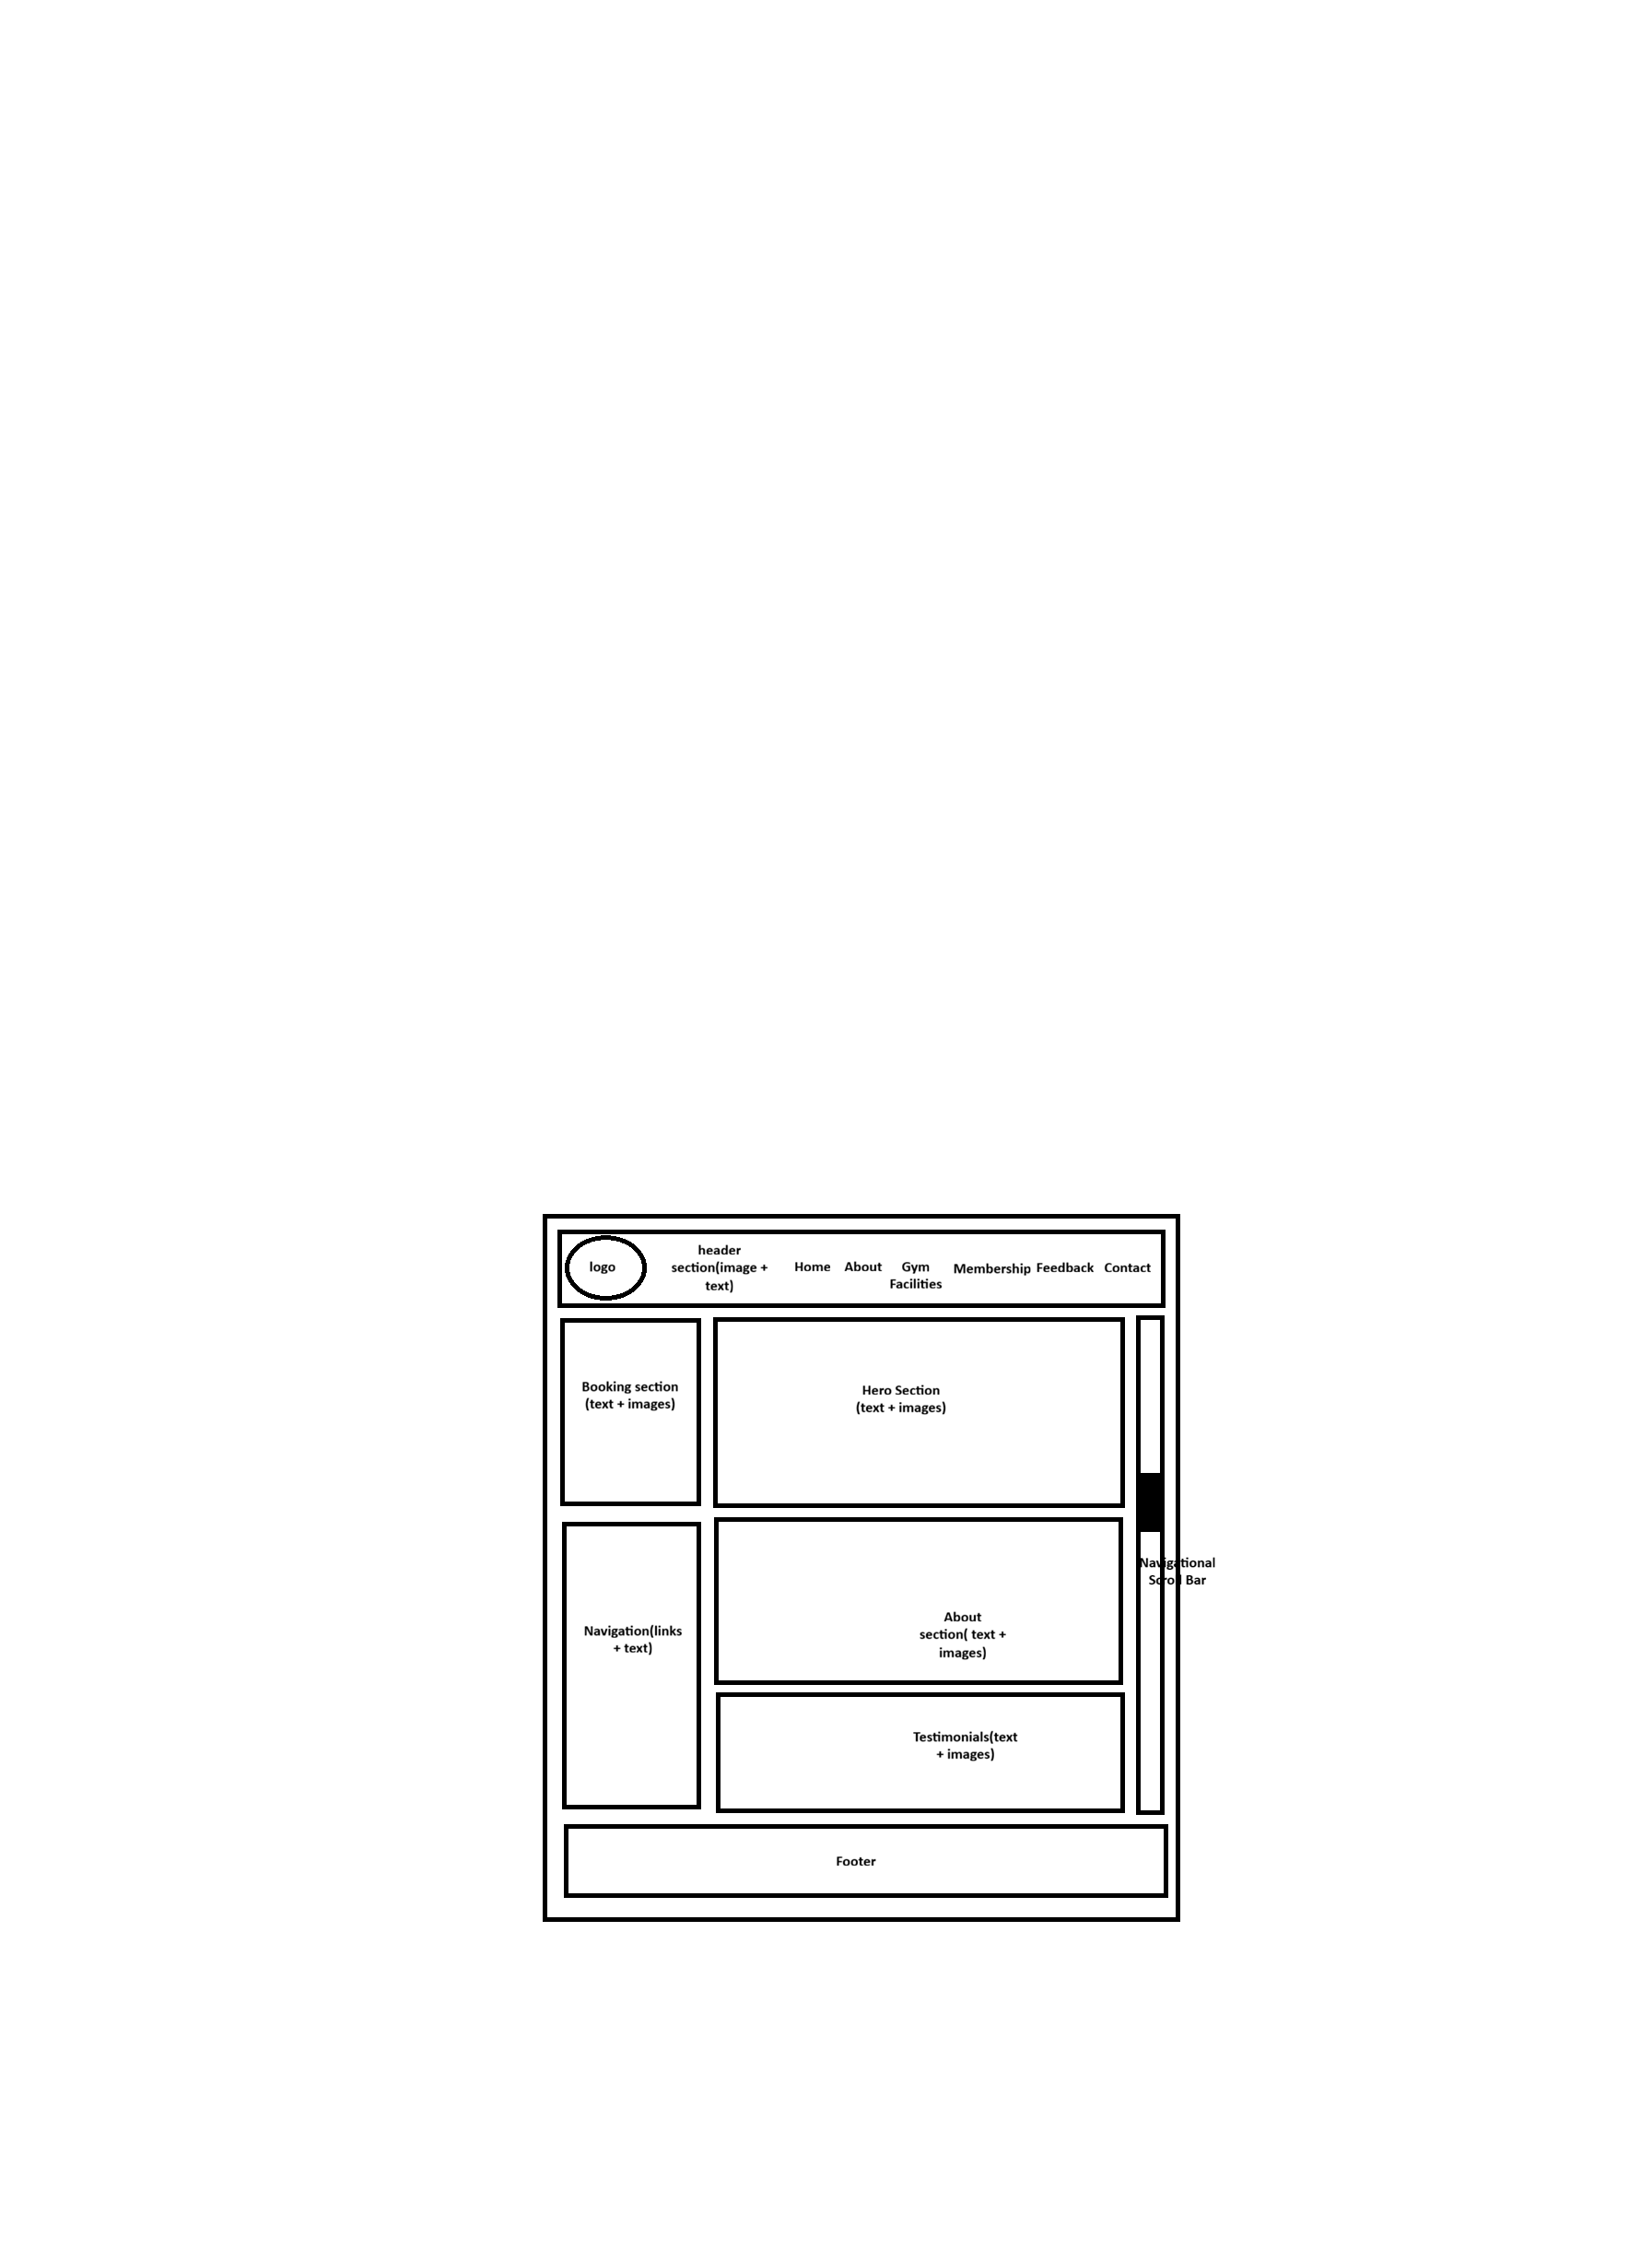

About Web Page
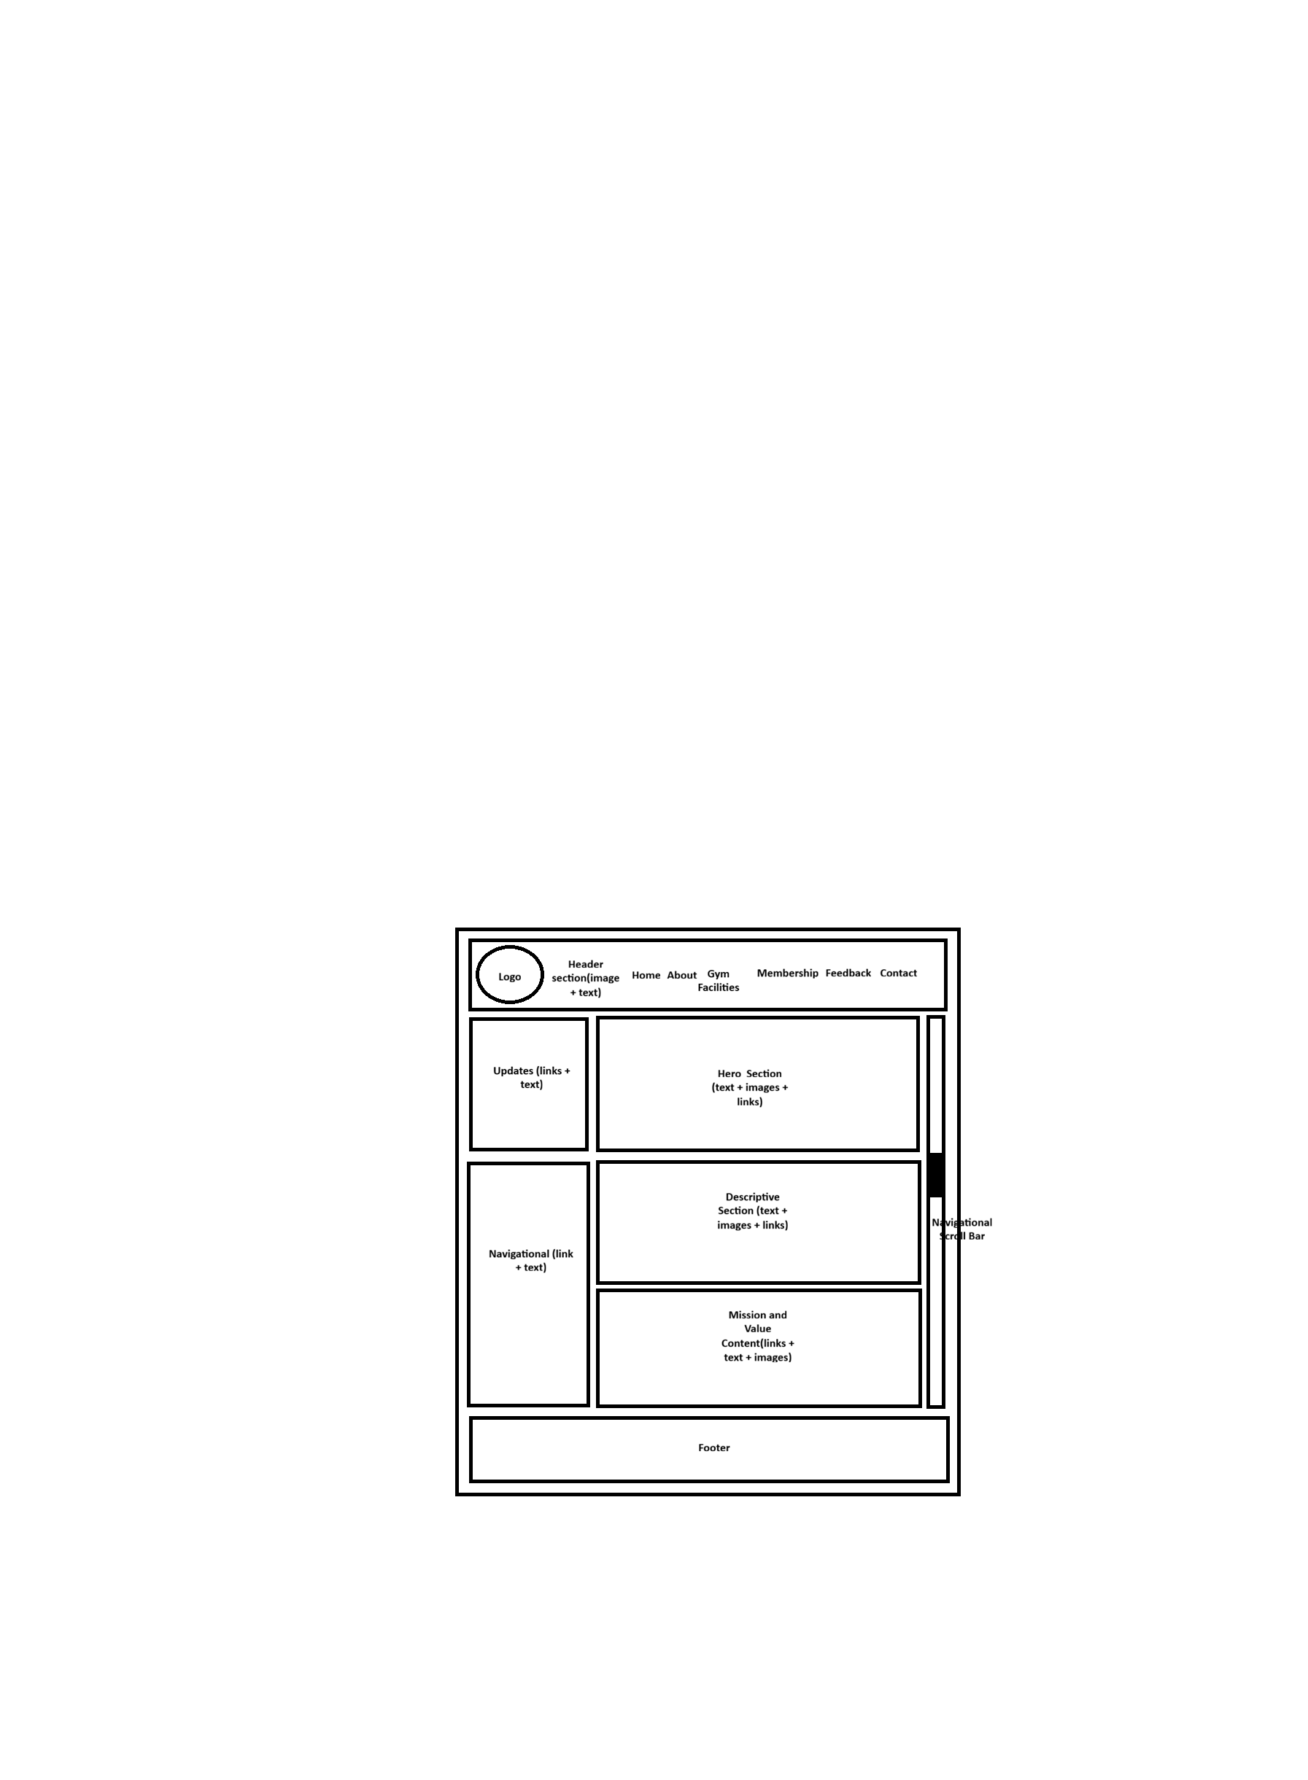

Gym Facilities Web Page
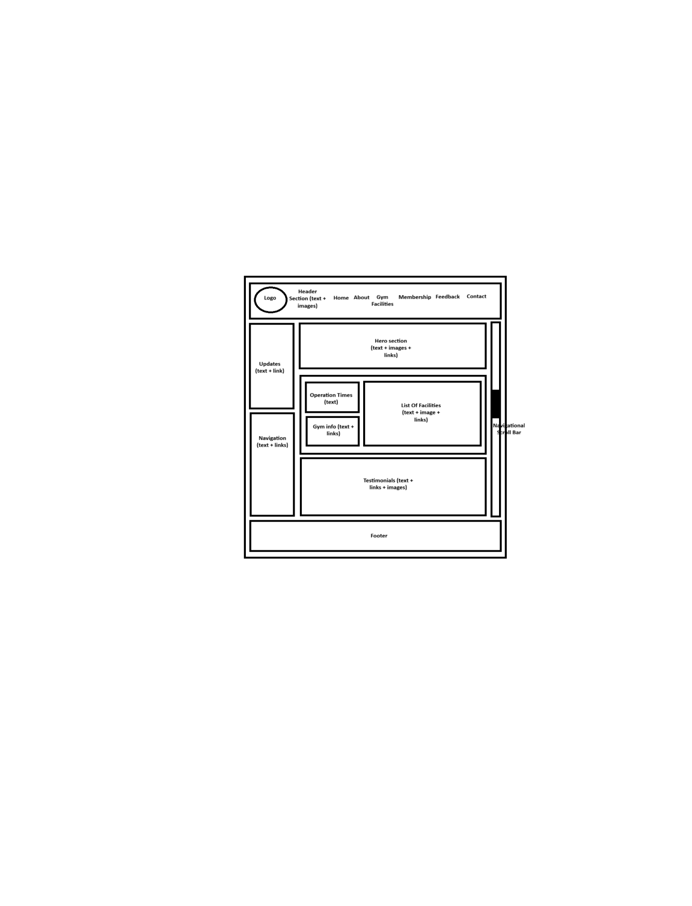

Membership Web Page
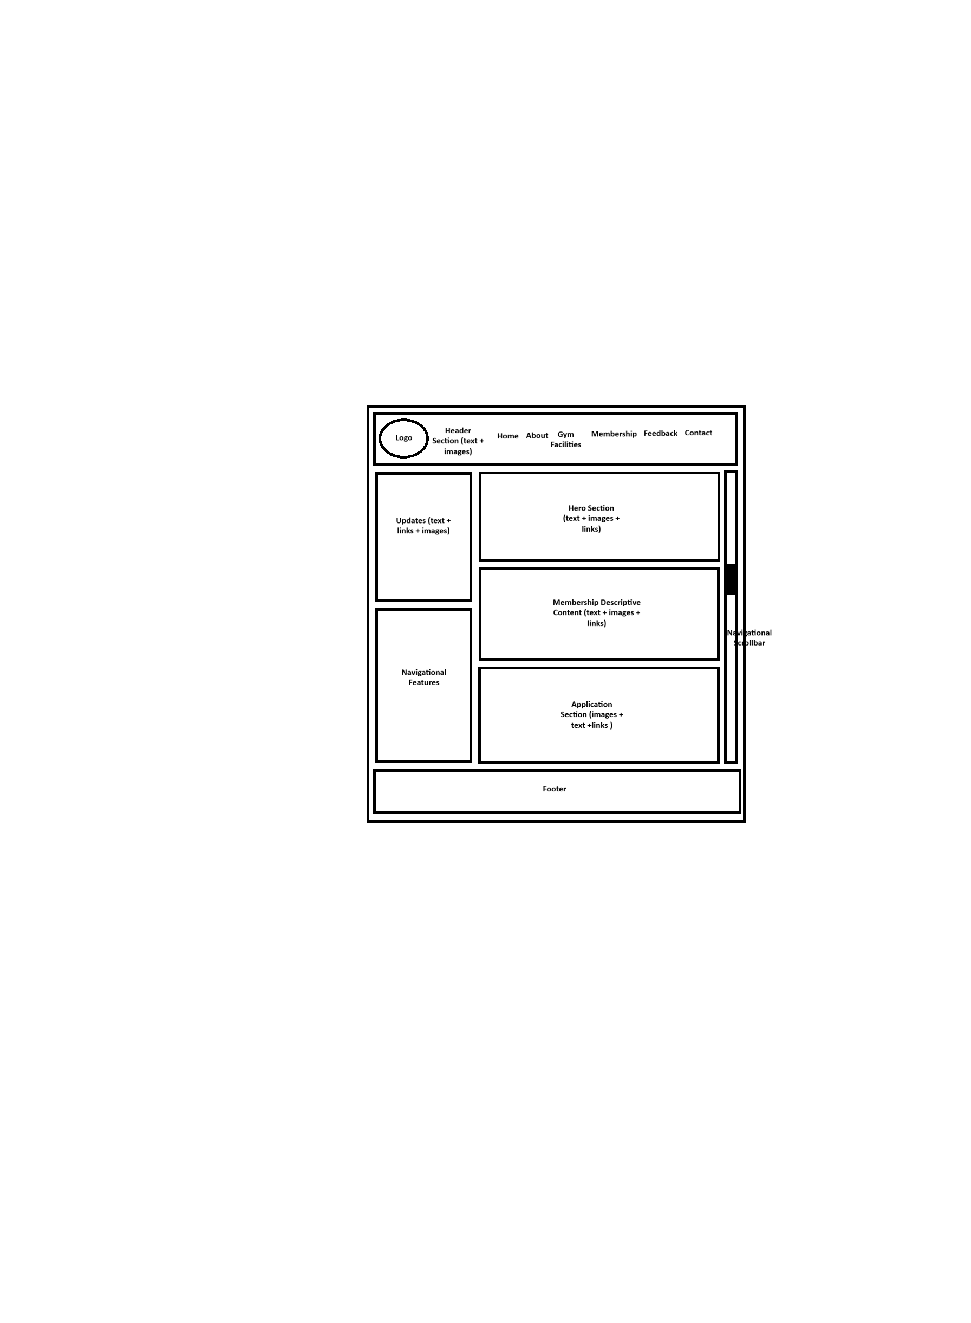

Feedback Web Page


Contact Web Page 